Ötzi the Ice Man Project
Due : _____________
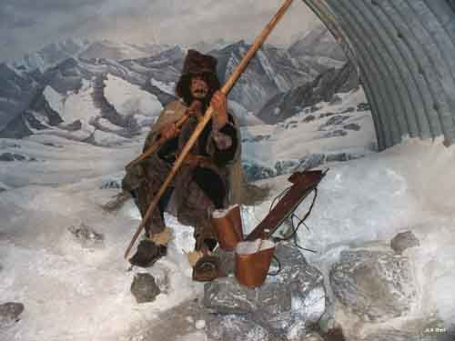

We have read about Otzi, seen videos and pictures of the 5,300 year old natural mummy commonly known as Otzi the Ice Man. Just as the anthropologists did, we attempted to draw conclusions about the life of Otzi.

Your assignment: Choose ONE of the three detailed Ice Man projects. Attached are the instructions and rubric for how each will be graded. *Please see the class website for additional websites for Ice Man information.

Choice A – 3 paragraph essay; After hearing all of the facts about Otzi, what is your theory about how he died?

Things to include:
- When and where was Otzi discovered?
- Who was Otzi (Iceman)?
- What is the name of the people who discovered Otzi?
- How old was the Iceman?
- Why was the discovery of Otzi important to history and how did he get his name?
- How did he die?
- Name some of the belongings found by Otzi and why was finding these artifacts important?
- Describe his last moments alive?
- Talk about his last meal and what he was found traveling with.
- Any other interesting facts
*Support your theories with facts that we have learned.

Choice B - Create an obituary & tombstone; Use the information provided in class to write what you believe Otzi’s life was like. You may change his name-we know that he was named years later after the mountain range he was found in. Include everything that you would like the world to know about Otzi and his life before that treacherous hike.

Otzi’s Obituary should be insightful and appropriate with the time he lived and walked the earth. Include all the information below in a creative manner.

Otzi’s obituary should include:

ANNOUNCEMENT: The name and residence of the person who died, and also place and cause of death.
BIOGRAPHICAL BACKGROUND: Birthplace, family, education, religion, occupation, jobs, military service, special pets, hobbies, interests, marriage, kids, etc. of the deceased.
SURVIVORS: Names of family members who survived the deceased.
When listing the all-important SURVIVORS make sure to include the following:
- Spouse and children
- Grandchildren
- Parents
- Brothers and sisters
- Grandparents

In addition, design Otzi’s Gravestone. Include his name, date of birth, date of death and a short quote about him.

*Support your theories with facts that we have learned.

Choice C – Newspaper page; Create a page in the newpaper all about the discovery of Otzi.
Sections should include, but are not
limited to:
- Newspaper Title
- Picture of Otzi
- Captivating Headline
- Short Obituary
- Article about how he was found
- Article about how he died
(your theory)

Things to include:
- When and where was Otzi discovered?
- Who was Otzi (Iceman)?
- What is the name of the people who discovered Otzi?
- How old was the Iceman?
- How did he die?
- Name some of the belongings found by Otzi and why was finding these artifacts important?
- Any other interesting facts

*Support your theories with facts that we have learned.

Name _______________________

Otzi Project Rubric

 | 1  Student did not meet expectations | 2  Student met minimal expectations | 3  Student met some expectations | 4  Student met all basic expectations | 5  Student exceeded expectations
Overall effort; Otzi project is on time & typed, or presented in neatest handwriting.
All required information is included.

Theories are proven with facts from the text, videos, or internet research.
Quality of writing; project is edited and revised.
Oral Presentation of project.

Total grade: _____________

Comments:

